1.What are the two values of the Boolean data type? How do you write them?

**True and False**.

2. What are the three different types of Boolean operators?

**and , or , and not**

3. Make a list of each Boolean operator's truth tables (i.e. every possible combination of Boolean values for the operator and what it evaluate ).

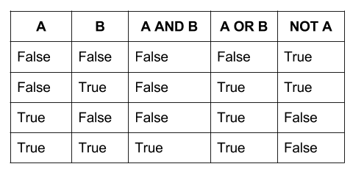

4. What are the values of the following expressions?

(5 > 4) and (3 == 5)- false

not (5 > 4)-false

(5 > 4) or (3 == 5)- true

not ((5 > 4) or (3 == 5))-false

(True and True) and (True == False)-false

(not False) or (not True)-true

5. What are the six comparison operators?

Less than ( < )

Less than or equal to ( <= )

Greater than ( > )

Greater than or equal to ( >= )

Equal to ( == )

Not equal to ( != )

6. How do you tell the difference between the equal to and assignment operators?Describe a condition and when you would use one.

The “=” is an assignment operator is used to assign the value on the right to the variable on the left. **The '==' operator checks whether the two given operands are equal or not**.

a=10

b=20

if a==10

print(“a”)

7. Identify the three blocks in this code:

spam = 0

if spam == 10:

print('eggs')

**IndentationError:** expected an indented block

if spam > 5:

print('bacon')

else:

print('ham')

print('spam')

print('spam')

**IndentationError:** expected an indented block

8. Write code that prints Hello if 1 is stored in spam, prints Howdy if 2 is stored in spam, and prints Greetings! if anything else is stored in spam.

spam = input()

if spam == '1':

print("Hello")

elif spam == '2':

print("Hawody")

else:

print("Greetings!")

9.If your programme is stuck in an endless loop, what keys you’ll press?

To stop code from running press the STOP button (black square)

10. How can you tell the difference between break and continue?

The Python break statement stops the loop in which the statement is placed. A Python continue statement skips a single iteration in a loop.

11. In a for loop, what is the difference between range(10), range(0, 10), and range(0, 10, 1)?

range(10) - start=0, stop=10, step=1

range(0, 10) - start=0, stop=10, step=1

range(0, 10,1) - start=0, stop=10, step=1

12. Write a short program that prints the numbers 1 to 10 using a for loop. Then write an equivalent program that prints the numbers 1 to 10 using a while loop.

for i in range(1, 11):

print(i)

i = 1

while(i<=10):

print(i)

i =i + 1

13. If you had a function named bacon() inside a module named spam, how would you call it after importing spam?

spam. bacon()